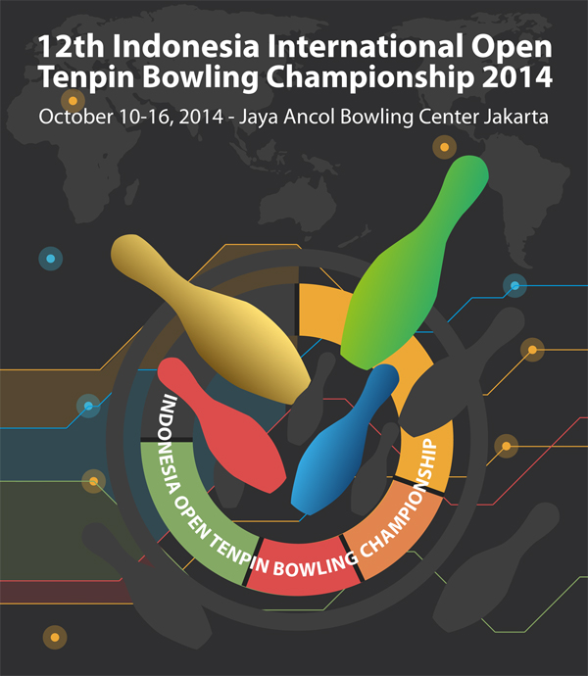
12th INDONESIA OPEN BOWLING CHAMPIONSHIP

18th – 26th October 2014, Jaya Ancol Bowling Center, Jakarta-Indonesia

HOTEL RESERVATION AND FLIGHT INFORMATION FORM
Date line submission before Sep 25, 2014. Kindly send us all the information below to:
Ms. Christina Koo
Jaya Ancol Bowling Center.
Jl. Lodan Timur Ancol Jakarta Utara – Indonesia.
Fax (6221) 640-5291 or Email: ancolbowl@yahoo.com
For details: Tel. (6221)-64710894.

PARTICIPANT
CITY NAME
COUNTRY
CONTACT PERSON
ADDRESS
TELEPHONE AND FAX NO.
EMAIL

OFFICIAL HOTEL
HOTEL (choose one) | NOVOTEL JAKARTA MANGGA DUA SQ. | ASTON MARINA ANCOL
NO OF SINGLE/DOUBLE
NO OF EXTRA BEDS
CHECK-IN DATE
CHECK-OUT DATE
NO. NIGHTS BOOKED
TELEPHONE AND FAX NO.
TOTAL NO. PERSONS

NOTES | NOVOTEL JAKARTA MANGGA DUA | ASTON MARINA ANCOL
Rates | 1 Standard Room for 1 or 2 persons  Rates Rp. 1.050.000,- Approx. US$ 89  All rooms are including breakfast and tax. | -1 Bedroom for 1 or 2 persons  Rates Rp. 775.000,- Approx. US$ 66  -2 Bedrooms for 4 persons (max)  Rates Rp. 1.275.000,- Approx. US$ 108  All rooms are including breakfast and tax.
Extra Beds | Rp. 490.000,- Approx US$ 42 | Rp. 250.000,- Approx US$ 22
Information | Novotel Jakarta Mangga Dua Square  Jl. Gunung Shari Raya No 1  Jakarta 14420, Indonesia  Tel : 62 21 6231 2800  Fax : 62 21 6231 2900  Website: http://www.novotel.com/ | Aston Marina Ancol  Marina Mediterania, Tower A  Jl. Lodan Raya No. 2A, Jakarta 14430  Tel : 62 21 698 37120  Fax: 62 21 698 37240  Website : http://www.astonmarinaancol.com

FLIGHT INFORMATION
ARRIVAL |  | DEPARTURE
DATE |  | DATE
TIME |  | TIME
FLIGHT NO. |  | FLIGHT NO
NO. OF PERSONS |  | NO. OF PERSONS

Kindly sign below along with your Name and Position

-----------------------------------------------------

