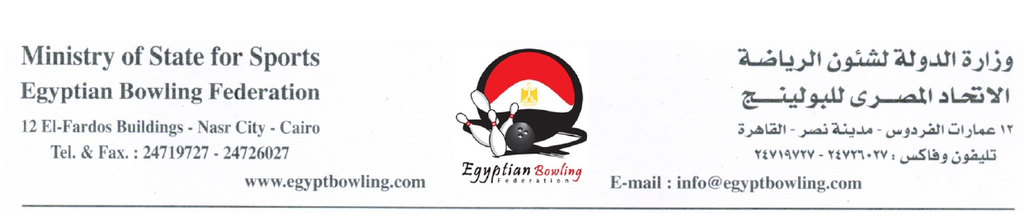

15th Sinai International Open Bowling Tournament
International Bowling Centre, Cairo, Egypt
24 - 30 April 2013

FORM-B: HOTEL/FLIGHT INFORMATION

Name of Federation:

OFFICIAL HOTEL
Fairmont Heliopolis | No. of Rooms
SINGLE
net (US$110)
(Bed & Breakfast & Internet)
DOUBLE / TWIN
net (US$140)
(Bed & Breakfast & Internet)
TRIPLE
net (US$165)
(Bed & Breakfast & Internet)

# | NAME | TYPE | # | NAME | TYPE

NB: All hotel bookings must be done through Egyptian Bowling Federation.

FLIGHT INFORMATION: ARRIVAL DETAILS DEPARTURE DETAILS
DATE: |  | DATE:
TIME: |  | TIME:
FLIGHT NO: |  | FLIGHT NO:
NO. OF PERSONS: |  | NO. OR PERSONS:

Signature: Date:
President / Secretary of National
Federation / Congress / Association

(Please complete this form and return on or before 1 April, 2013)
Fax: +202-24719727 or Email: info@egyptbowling.com, Gamal-bowling@hotmail.com

