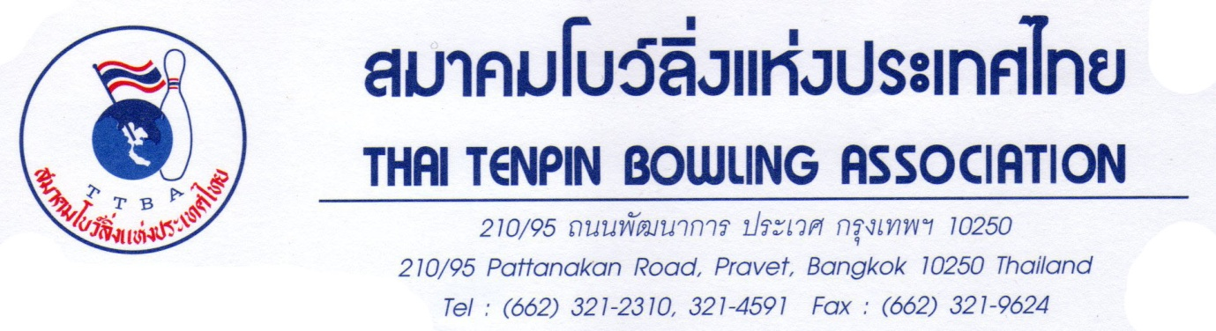
February 1, 2012

To : Member Federation of ABF / WTBA

Re : INVITATION TO PARTICIPATE IN 38th THAILAND INTERNATIONAL OPEN BOWLING CHAMPIONSHIP 2012

Dear Sir / Madame.

On behalf of Thai Tenpin Bowling Association, We are pleased to take pleasure in inviting your federation / Congress / Association / Bowling Club / Bowling Teams to participate in The 38th Thailand International Open Bowling Championship 2012. The tournament will be held at the SF Strike Bowl Ngamwongwan, Nontaburi from April 6 to April 18, 2012.

The Thailand International Open is organized by the Thai Tenpin Bowling Association and Sanction by the Asian Bowling Federation and WTBA, it will be conducted under FIQ / WTBA Rulers and Regulations. The Championship is an Asian Ranking Tournament towards the World Ranking Master Finals. It will also serve as a qualifying round to wards. the ABF Tour 2012, that will take place on the 19th of April 2012. (The top 16 Asian men and 16 Asian women) in the Open Masters. Final will be eligible to participate in the ABF Tour, Thailand.)

The Official Hotel is Chaophya Park Hotel. The room rate is ฿2300 (approx. US$ 74) inclusive of services charges and tax. The offer includes breakfast and transportation. This rate will only apply when reservations are made through our Association.

Enclosed, please also find copies of the 38th Thailand Open Rules and Regulations, tournament squad schedules, prizes and fees, as well as confirmation forms. Presently, we have give priorities to overseas and out of state bowlers on the last 5 qualifying days. However, to ensure your preferred squad schedules, we encourage that you send your confirmations at your earliest convenience.

Thank you for your support and attention. We shall look forward to seeing your bowlers in April. See you in Thailand.

Yours Sincerely
Thai Tenpin Bowling Association

Suwalai Satrulee
Secretary General
ENTRY FORM

Name of Congress/Federation: ____________________________________________
Contact Person: ________________________________________________________
Tel No: _______________ Fax No: _______________ E-mail: _________________

No of Participants : (M)____________ (F)___________
No of Officials : (M)____________ (F)___________

HOTEL RESERVATION: CHAOPHYA PARK HOTEL (BANGKOK)
Deluxe room, | Single/Twin | Baht 2,300 | (Approx U$ 74)
Business Deluxe room, | Single/Twin | Baht 2,600 | (Approx U$ 84)
Executive room, | Single/Twin | Baht 3,200 | (Approx U$ 103)
Suite room, | Single/Twin | Baht 4,200 | (Approx U$ 135)
Extra bed |  | Baht 1,000 | (Approx U$ 32)

Single | Double | Triple | Check-in Date | Check-out Date

FLIGHT INFORMATION

Arrival Details:
Arrival Date | Arrival Time | Flight No | No of Person

Departure Details:
Departure Date | Departure Time | Flight No | No of Person

Please return this form to us by fax (662) 321-9624 or e-mail
For enquiries, please contact our office: Tel: 66 81 823 7918
E-mail: suwalaisatrulee@hotmail.com

