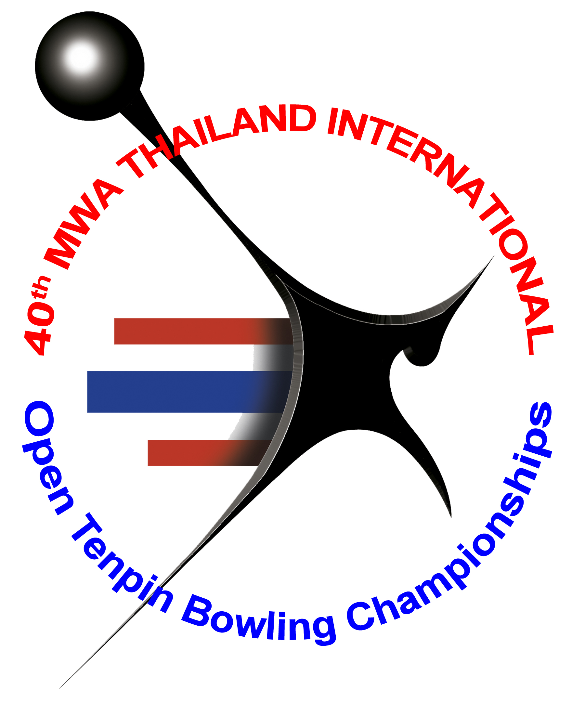
ENTRY FORM

Name of Congress/Federation: _____________________________________________
Contact Person: ________________________________________________________
Tel No: _______________ Fax No: _______________ E-mail: __________________

No of Participants : (M)____________ (F)___________
No of Officials : (M)____________ (F)___________

HOTEL RESERVATION: CHAOPHYA PARK HOTEL (BANGKOK)
Deluxe room, | Single/Twin | Baht 2,300 | (Approx U$ 76)
Business Deluxe room, | Single/Twin | Baht 2,600 | (Approx U$ 86)
Executive room, | Single/Twin | Baht 3,200 | (Approx U$ 106)
Suite room, | Single/Twin | Baht 4,200 | (Approx U$ 140)
Extra bed |  | Baht 1,000 | (Approx U$ 33)

Single | Double | Triple | Check-in Date | Check-out Date

FLIGHT INFORMATION

Arrival Details:
Arrival Date | Arrival Time | Flight No | No of Person

Departure Details:
Departure Date | Departure Time | Flight No | No of Person

Please return this form to us by fax (662) 321-9624 or e-mail
For enquiries, please contact our office: Tel: 66 81 823 7918
E-mail: suwalaisatrulee@hotmail.com

