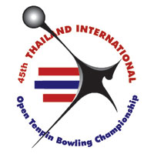
45th MWA-Singha Thailand International
Tenpin Bowling Championships 2019

SQUAD BOOKING
GRADE OPEN

Name | M | F | Country | Squad
 |  |  |  | A | B | C | D

Please return this form to us by fax (662) 321-9624 or e-mail
For enquiries, please contact our office: Tel: 66 81 823 7918
E-mail: suwalaisatrulee@hotmail.com

