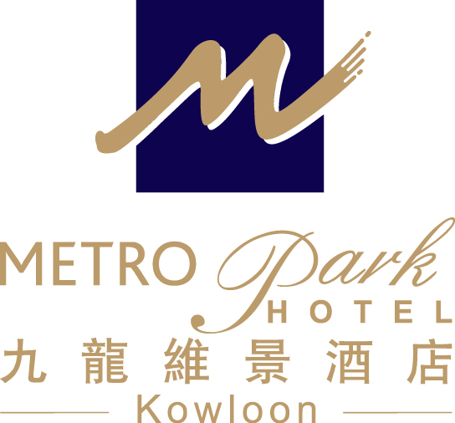
Form E
Page 1
Form E
Page 1

22nd Asian Tenpin Bowling Championships (22nd AC)
01 – 11 September, 2012
Hong Kong Bowling City, G/F, Emax-KITEC, 1 Trademart Drive, Kowloon Bay, Kowloon, Hong Kong
Organized by Hong Kong Tenpin Bowling Congress Limited

FLIGHT & ACCOMMODATION INFORMATION FORM
(Please complete this form and return on or before 30 June, 2012)

Country:

Contact Person: Mr / Ms / Mrs ____________________________________________________________________
Address:______________________________________________________________________________________
Contact Tel no.: _________________________________ Fax no.:______________________________________
E-mail: _______________________________________________________________________________________

Flight Information:
Arrival |  |  |  | Departure
Arrival  Date | Arrival  Time | Flight No. | No. of Person | Departure Date | Departure  Time | Flight No. | No. of Person
Hotel Reservation:
Hotel Information – Metropark Hotel Kowloon
Address |  | 75 Waterloo Road, Kowloon, Hong Kong
Contact Person |  | Ms. Anita Hung – Business Development Manager
Tel |  | (852) 2197 3431
Fax |  | (852) 2760 3603
Email |  | abdm.hkkl@metroparkhotels.com
Superior Room |  | *Daily Room Rate (HK$) with Buffet Breakfast |  | Privileges
HK$950.00net Single Occupancy  HK$1030.00net Double Occupancy |  |  |  | - Complimentary buffet breakfast at Palm Court Western Restaurant on 1/F  - Daily newspaper  - Free in-room broadband Internet access (unlimited usage)  - Welcome fruit set-up and beverages upon arrival  - Free local telephone calls  - Free shuttle bus services to/from Mongkok MTR station, shopping district and the Tsimshatsui waterfront  - 50% discount on the service charge for IDD calls and Business Centre Services  - Free use of fitness room facilities & Hotel’s swimming pool (open from March to December)
*The above room rates are inclusive of 10% services charge
Form E
Page 2
Special Request
Double Bed (subject to availability) Twin Bed Non-Smoking Smoking (subject to availability)
Guarantee of room(s)

Booking Guaranteed by |  |  | Amex Visa Master
Credit Card No. |  |  |  |  | Expiry Date (mm/yy)
Name of Card Holder
Please remit payment in credit card at hotel or wire the amount to our bank accounts. Bank account details:
Banker  Address  Beneficiary  Account No.  Swift Code | : Hang Seng Bank Ltd  : 86 Waterloo Road, Kowloon  : Metropark Hotel Kowloon Hong Kong  : 024-242-128288-001  : HASEHKHH

Remarks:

- Reservation request form and guarantee must be submitted to Metropark Hotel Kowloon on or before 30 June 2012. All reservation requests are subject to hotel confirmation. All bookings are on a first-come-first-serve basis.
- All bookings must be guaranteed by a valid credit card or T.T. of one night room charge of the rooms booked.
- Deadline for room cancellation (in writing) must be on or before 31 July 2012. One night room charge of the rooms booked forfeiture applies if cancellation is made after the deadline.
- In case of no-show on the date of arrival or amendment notification made less than 48 hours prior to arrival, one night room charge of the rooms booked forfeiture will be applied.
- Reservation outside the above valid period is subject to the prevailing rate and hotel availability.
- Metropark Hotel Kowloon reserves the right of final decision in case of any disputes.

HOTEL USE ONLY

CONFIRMED WAITING LIST NOT CONFIRMED

By Remarks Date

Form E
Page 3
22nd Asian Tenpin Bowling Championships (22nd AC)
01 – 11 September, 2012
Hong Kong Bowling City, G/F, Emax-KITEC, 1 Trademart Drive, Kowloon Bay, Kowloon, Hong Kong
Organized by Hong Kong Tenpin Bowling Congress Limited

ROOMING LIST
(Please complete this form and return on or before 30 June, 2012)

Federation: _______________________________________________

Country: _________________________________________________

Total no. of participants: ____________________________________

Total no. of rooms required: _________________________________

* Please mark T for Team, MD for Meeting Delegate, G for Guest, S for Supporter, Med for Media
Room | *T / MD / G / S / Med | Title | First Names | Last Names | Room Type
1 |  |  |  |  | Single / Double Occupancy
2 |  |  |  |  | Single / Double Occupancy
3 |  |  |  |  | Single / Double Occupancy
4 |  |  |  |  | Single / Double Occupancy
5 |  |  |  |  | Single / Double Occupancy
6 |  |  |  |  | Single / Double Occupancy
7 |  |  |  |  | Single / Double Occupancy
8 |  |  |  |  | Single / Double Occupancy
9 |  |  |  |  | Single / Double Occupancy
10 |  |  |  |  | Single / Double Occupancy

