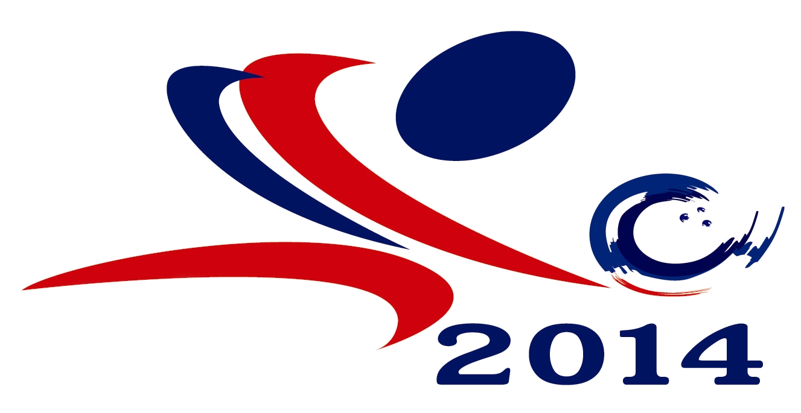

23rd Asian Tenpin Bowling Championships
January 14 – 26, 2015
Blu – O Rhythm & Bowl Ratchayothin, Thailand

Form B : Entry Form
(To be completed and returned to TTBA on or before November 1, 2014)

Federation:

 |  |  |  | Family Name | Given Name | Chinese name  (if any)
Male Bowlers |  |  | 1.
 |  |  | 2.
 |  |  | 3.
 |  |  | 4.
 |  |  | 5.
 |  |  | 6.
Female Bowlers |  |  | 1.
 |  |  | 2.
 |  |  | 3.
 |  |  | 4.
 |  |  | 5.
 |  |  | 6.
Team  Officials |  | Titles
Team  Officials | 1.
Team  Officials | 2.
Team  Officials | 3.
Team  Officials | 4.
Team  Officials | 5.
Team  Officials | 6.
Team  Officials | 7.

23rd Asian Tenpin Bowling Championships
January 14 – 26, 2015
Blu – O Rhythm & Bowl Ratchayothin, Thailand

Country Official Abbreviation

This ENTRY FORM, accompanied with 2 recent photos of each participant and official, must reach the Host Federation on or before November 1, 2014

Contact Person : _________________________________

Telephone : _________________________________

Fax : _________________________________

Email : _________________________________

Postal Address :

_______________________________________________________________________________

____________________________________
*President / Secretary General
of the National Association / Congress
Signature and Seal

*Please whichever inappropriate

