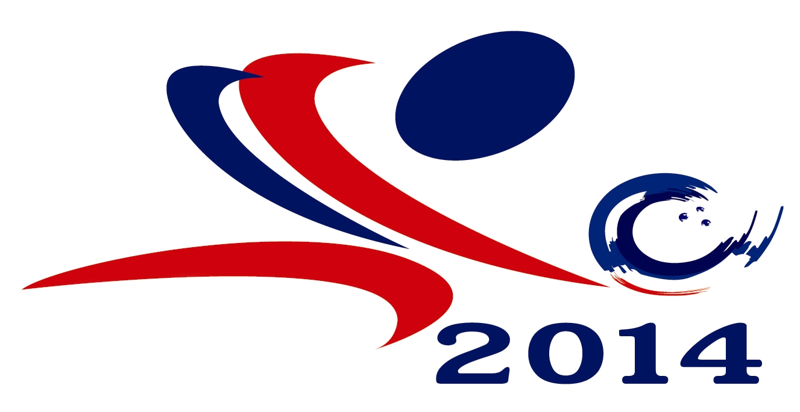

23rd Asian Tenpin Bowling Championships
January 14 – 26, 2015
Blu – O Rhythm & Bowl Ratchayothin, Thailand

Form C : Bowler’s Information Form
(To be completed and returned to TTBA on or before November 1, 2014)
Country: Federation:

Name (English): ( )
Family Name Given Name Chinese Name (if any)

Date of Birth: Place of birth: dd / mm / yy

*Left / Right handed High Game: Average:

High series (3 games): 6 games):

Bowling Experience: years Years in National Team years

Major Bowling Achievements (Games, Asian /World Championships)

Signature: Date:
*President / Secretary General
of the National Federation / Congress
Signature and Seal

* Please whichever inappropriate

