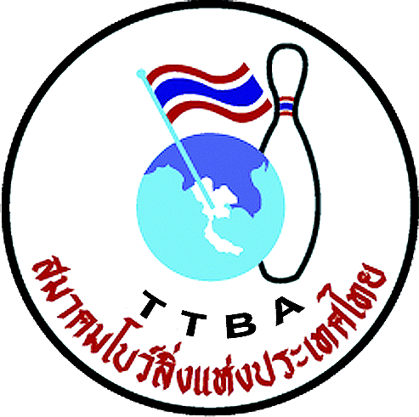 |    | 13

Form A: Entry Form
Please return this form even if you do not want to participate in the WYC 2012

Federation 

Confirmation
We want to participate (Yes/No)

The delegation
Number of players in the team
Number of officials connected to the team

Contact information
Contact person
Address
Phone
Mobile
Fax
E-mail

The ultimate deadline of submitting this form is March 30th, 2012
Your contact person in the WYC 2012 Organizing Committee is MRS. SUWALAI SATRULEE
Phone | Mobile | Fax | E-mail address
+ 662 321 - 4591 | + 668 1823 7918 | + 662 321 - 9624 | Suwalaisatrulee@hotmail.com

