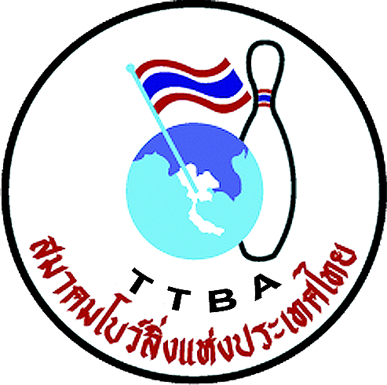 |    | 14

Form B: Hotel Form for CENTARA GRAND at Central World
Please return this form even if you are accommodating your delegation at another hotel!

Federation 

Are using another accommodation?

Number of rooms | Type of rooms | Arrival date | Departure date

The payment must take place directly to Thai Tenpin Bowling Association before arrival.

The ultimate deadline of submitting this form is April 30th, 2012
Your contact person in the WYC 2012 Organizing Committee is MRS. SUWALAI SATRULEE
Phone | Mobile | Fax | E-mail address
+ 662 321 - 2310 | + 668 1 8237918 | + 662 321 - 9624 | Suwalaisatrulee@hotmail.com

