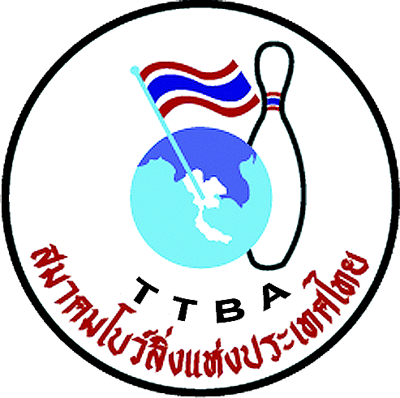 |   

Form C: Room list with names

Federation 

Your delegation divided at the hotel rooms
Room | Type | Please type all names at the room
1
2
3
4
5
6
7
8
9
10
11
12

Type of rooms (field no. 2 to in the table above):
1 = Single Room / 2 = Double Room / 3 = Three Bed Room

WYC 2012 Secretariat: Thai Tenpin Bowling Association
Phone: +668 1823 7918 Fax: +662 321-2310, e-mail: Suwalaisatrulee@hotmail.com.
Website: www.worldyouth2102.com
Address: 210/95 Pattanakan Rd. Pravet, Bangkok 10250. THAILAND

