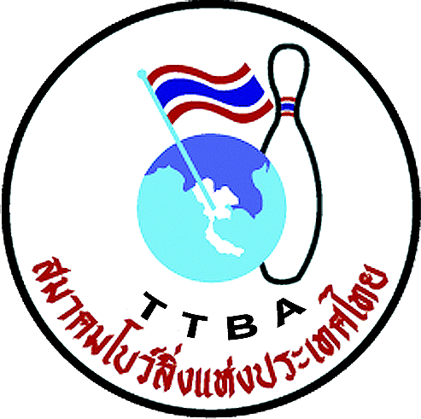 |   

Form D: Arrival and departure

Federation 

Arrival information
Number of people
Date in digital presentation
Time in digital presentation
Flight No.

Departure information
Number of people
Date in digital presentation
Time in digital presentation
Flight No.

WYC 2012 Secretariat: Thai Tenpin Bowling Association
Phone: +668 1823 7918 Fax: +662 321-2310, e-mail: Suwalaisatrulee@hotmail.com.
Website: www.worldyouth2012.com
Address: 210/95 Pattanakan Rd. Pravet, Bangkok 10250. THAILAND

