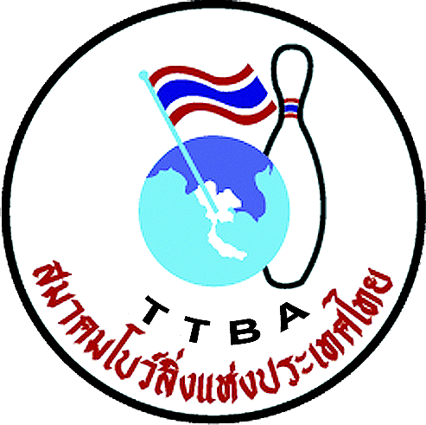 |   

Form E: Names in delegation

Federation 

Players
Name (first name, family name) | Function
 | Lady player
 | Lady player
 | Lady player
 | Lady player
 | Male player
 | Male player
 | Male player
 | Male player

Officials
Name (first name, family name) | Function

WYC 2012 Secretariat: Thai Tenpin Bowling Association
Phone: +668 1823 7918 Fax: +662 321-2310, e-mail: Suwalaisatrulee@hotmail.com.
Website: www.worldyouth2012.com
Address: 210/95 Pattanakan Rd. Pravet, Bangkok 10250. THAILAND

