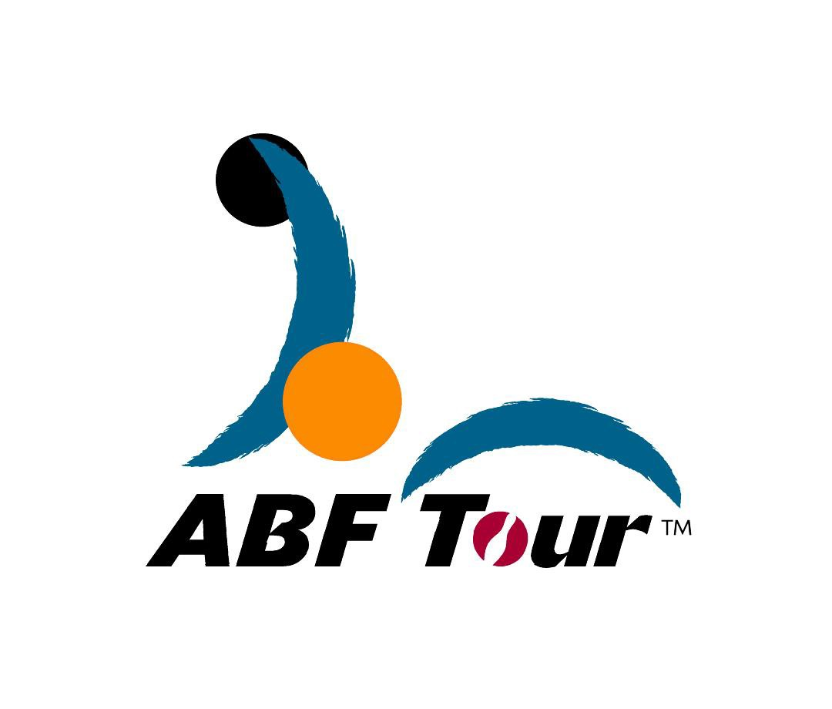
ABF TOUR 2015
Saudi leg

Reply Slip for Intention of Participation
(To be completed and returned to the tournament secretariat before bowling
your first game)

To : ASIAN BOWLING FEDERATION

From :
(name of bowler)

(country)

I have read the attached rules and regulations for the ABF Tour.

I * Intend to participate in the ABF TOUR SAUDI LEG 2015

* DO NOT intend to participate in the ABF TOUR SAUDI LEG 2015

*Please  whichever is appropriate

Signature:

Date

Signature of bowler

