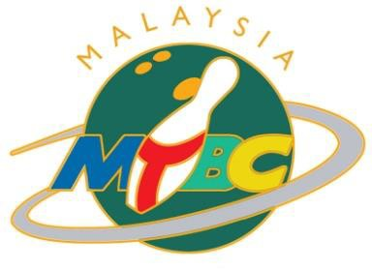

**MALAYSIAN TENPIN BOWLING CONGRESS**

c/o Sunway Mega Lanes, Lot F2.22, Level 1, Sunway Pyramid, 3 Jalan PJS 11/15, Bandar Sunway 46150 Petaling Jaya

Tel: 603-74923226 Fax : 603-74923227 Email : [administrator@mtbc.org.my](mailto:administrator@mtbc.org.my)

**FORM G**

**22ND ASIAN YOUTH TENPIN BOWLING CHAMPIONSHIP 2025  
20 – 28 AUGUST 2025, MALAYSIA**

**UNOFFICIAL PRACTICE LANE RESERVATION FORM**

(To be completed and returned to MTBC on or before 1 AUGUST 2025)

To : Malaysian Tenpin Bowling Congress  
 Email : [malaysianbowling@gmail.com](mailto:malaysianbowling@gmail.com) / [kychok@gmail.com](mailto:kychok@gmail.com)

|  |  |
| --- | --- |
| FEDERATION |  |

**Timeslots available for unofficial practice: 18 – 20 August 2025, 1000 hrs – 2200 hrs)  
 Lane Fees: RM 60 per hour per lane**

|  |  |  |  |  |
| --- | --- | --- | --- | --- |
| **Date** | **Time  (Start)** | **No. of Hours** | **No. of Lanes** | **For Official Use** |
|  |  |  |  |  |
|  |  |  |  |  |
|  |  |  |  |  |
|  |  |  |  |  |
|  |  |  |  |  |

Lane reservation is only available from 18 – 20 August 2025, on first-come-first-served basis.

Maximum booking for each federation if 4 lanes for every 2 hours if time slot is full, but teams may extend the unofficial practice time or number of lanes, if the lanes have not been reserved by another federation. The fees for unofficial practice must be paid in RM (Credit Card Only), directly to Sunway Mega Lanes (They are cashless). All bookings must be made through MTBC and subject to availability of Sunway Mega Lanes.

**Signature : Seal :   
 President or Secretary General  
 of the Federation**

**Date :**

TOGETHER WE SERVE TO BETTER OUR SPORT

P a g e | **1**