PERSATUAN BOLING INDONESIA
Gedung Direksi Gelora Bung Karno / KONI Pusat Lt. 8 Jalan Pintu I, Senayan Jakarta 10270
Mobile: +62 811 1111 421, Email: pbi_org@yahoo.com

Form A
25th Asian Junior Tenpin Bowling Championships, Jakarta, Indonesia
August 21 - 30, 2026
INTENTION OF PARTICIPATION REPLY SLIP
(To be completed and returned to ABF and PBI on or before 30 June 2026) Email: hktbc@netvigator.com and pbi_org@yahoo.com

Name of Federation


We intend to participate in the 25th Asian Junior Tenpin Bowling Championships

🗆​ Boys’ Team | 🗆​ *One | 🗆​ *Two (Maximum 2 Boys’ Team)
🗆​ Girl’s Team | 🗆​ *One | 🗆​ *Two (Maximum 2 Girls’ Team)


We do not intend to participate in the 25th Asian Junior Tenpin Bowling Championships
*Please ☑ whichever is applicable.


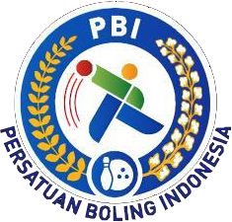
Signature: President or Secretary General

Date: / /2026
DATE MONTH
Seal:

