U22 3rd Fukuoka Summer Cup
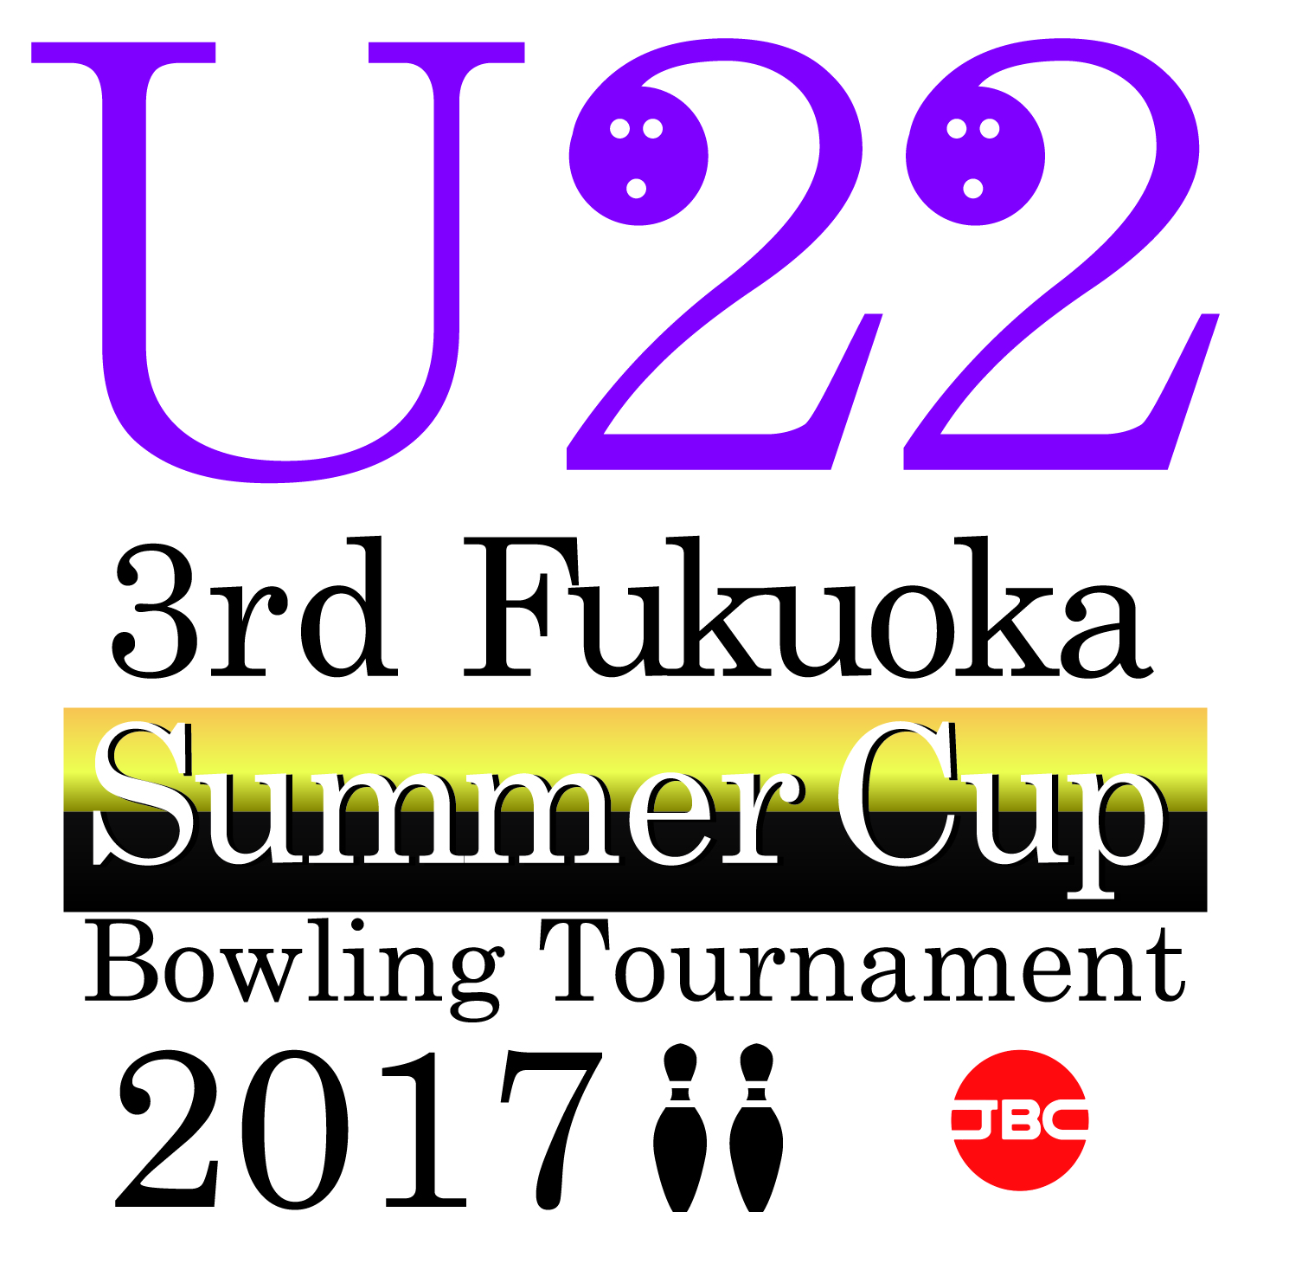 | Bowling Tournament 2017
 | sponsored by STORM
 | 【 Entry Form】

Name of Federation: |  | ___________________________________________________________________

Officials
Name | Status

Bowlers
# | NAME | GENDER | AGE
1
2
3
4
5
6
7
8
9
10
11
12

Signature: | ________________________________________ |  | Date: |  | ____________________
 | President or Secretary General
 | of the National Federation / Congress / Association

Kindly fax OR e-mail this form back on or before June 30, 2017

Email: info@kyushu-fbf.jp
Fax: +81 – 92 – 433–6166

