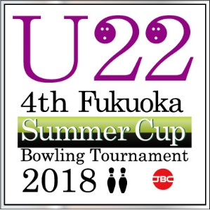
U22 4th Fukuoka Summer Cup

Bowling Tournament 2018
sponsored by

【 HOTEL/FLIGHT INFORMATION 】

Official Hotel : HAKATA GREEN One Hotel
: 4-4 Hakata-eki Chuogai, Hakata-ku, Fukuoka Prefecture 812-0012, Japan
Single Room : ¥9,700 ++ inclusive of Breakfast (13 m²)
Twin Room : ¥8,200++/pax, inclusive of Breakfast (17 m² )
Extra Twin Room : ¥9,200++/pax, inclusive of Breakfast (18 m²)
Triple : ¥7,200++/pax, inclusive of Breakfast (23 m²)

Name of Federation :

Name on room (Single room)
# | NAME
1
2

Name on room (Twin room) / (Extra Twin Room ) *pls identify type of twin room
# | NAME
1
2

Name on room (Triple)
# | NAME
1
2

FLIGHT INFORMATION: |  | ARRIVAL DETAILS |  |  |  |  |  | DEPARTURE DETAILS
DATE: |  |  |  | DATE:
TIME: |  |  |  | TIME:
FLIGHT NO: |  |  |  | FLIGHT NO:
NO. OF PERSONS: |  |  |  | NO. OF PERSONS:

Signature : Date :

Email: info@kyushu-fbf.jp
Fax: +81 – 92 – 433–6166

