U22 8th Fukuoka Summer Cup | 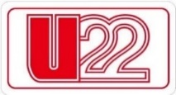
Bowling Tournament 2025
sponsored by STORM | 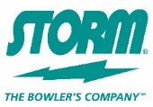
【 Hotel / Flight Form 】

Name of Federation: |  | ________________________________________________________________

NAME of the HOTEL you stay
(Please let us know as we need it for your transportation)
# | HOTEL NAME
1
2
3

FLIGHT INFORMATION: |  | ARRIVAL DETAILS |  |  |  |  |  | DEPARTURE DETAILS
DATE: |  |  |  | DATE:
TIME: |  |  |  | TIME:
FLIGHT NO: |  |  |  | FLIGHT NO:
NO. OF PERSONS: |  |  |  | NO. OF PERSONS:

Signature: | ________________________________________ |  | Date: |  | ____________________
 | President or Secretary General
 | of the National Federation / Congress / Association

Kindly E-mail this form back on or before July 18, 2025
Email: tybowling300@gmail.com

