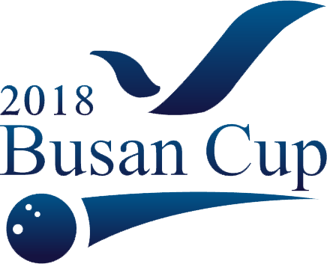

2018 PBA-WBT Busan Cup
International Open Bowling Tournament
(Major World Bowling Tour)

EMTRY FROM with Flight INFO
Contact person: Country: Group:
Email: Telephone:
BOWERS INFO (Open/ Women/General Division)
Name | Gender | DOB | Coach | Email | O | W | G
OFFICIAL HOTEL PARAGON RESERVATION (Double/Twin: 88,000KRW)
Guest Names/room | Doub/Twin | Room Number | Check In Date | Check Out Date
FLIGHT DETAILS & Transport from Airport
Arrival Date/Time/Flight#/Airport | Departure Date/Time/ Flight# | Bus/KTX/Van
Please contact Kitty for any question, and return this form to kittybaek1@gmail.com

