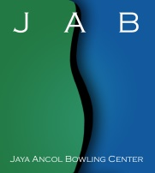
JAYA ANCOL SINGLES CHAMPIONSHIPS 2018
Jaya Ancol Bowling Center, Jakarta, Indonesia
29 April – 5 May 2018

ENTRY FORM

NAME:

FEDERATION/COUNTRY:

CONTACT PERSON:

ADDRESS:

TELEPHONE NO:

EMAIL:

PREFERRED SQUAD (Please specify number of slots required):

SQUAD A | SQUAD B | SQUAD C | SQUAD D

BOWLERS & OFFICIALS:

NO | NAME | DIVISION | GENDER | DESIGNATION

FLIGHT INFORMATION:

ARRIVAL |  | DEPARTURE
DATE |  | DATE
TIME |  | TIME
FLIGHT NO. |  | FLIGHT NO.
NO. OF PERSONS |  | NO. OF PERSONS

SIGNATURE/POSITION

